1. <https://github.com/nicolaivicol/otto-recommender> (đã viết)

Follow theo flow: candidate generation -> re-rank -> top 20

Kết quả

* Features dùng:
* Reranker model dùng:

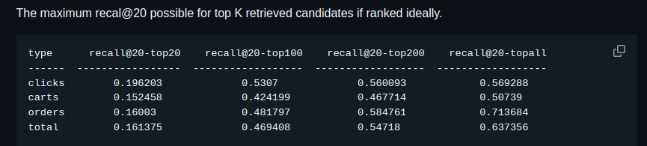

2. <https://github.com/TheoViel/kaggle_otto_rs>

Tương tự: candidate generation -> re-rank

Kết quả

* Features dùng:
* Reranker model dùng:

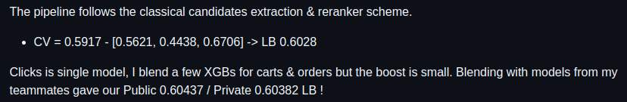

3. <https://github.com/nlztrk/OTTO-Multi-Objective-Recommender-System>

4. <https://github.com/p4zaa/OTTO-Multi-Objective-Recommender-System>

5. <https://github.com/kiccho1101/kaggle-otto2> done

6. <https://github.com/EmmaHLU/otto-recommender>

Transformer? Tiếp cận theo hướng time series

7. [cdeotte/Kaggle-OTTO-Comp](https://github.com/cdeotte/Kaggle-OTTO-Comp) - top 3 - [OTTO – Multi-Objective Recommender System | Kaggle](https://www.kaggle.com/competitions/otto-recommender-system/discussion/383013)